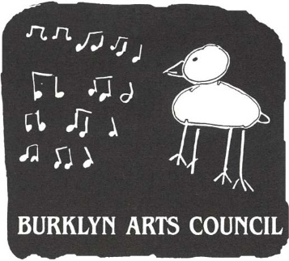
BURKLYN ARTS COUNCIL
Burklyn use

post mark date_______

booth assignment ____
PO Box 1056, Lyndonville, VT 05851

51st Annual Burklyn Summer Craft Fair, July 3, 2021
10 a.m. to 4 p.m., Bandstand Park, Lyndonville, Vermont

Application Form

APPLICATION DEADLINE—June 1
This application is also available online at Burklyn-Arts.org

Name _____________________________________________________________________ Phone_____________
Business Name______________________________________________________________ Craft______________
Address_______________________________________________________________________________________
E-mail address________________________________ License plate number________________________________

Fees and booth selection.
We will do our best to honor your choices. The map below is just for reference. The actual layout may differ.

[ ] Tenured exhibitor 2021 membership fee $25
[ ] New applicant jury fee $15___
[ ] 12' x 12' EZup space $105
[ ] Electricity (CFLs/LEDs please) ___ $25 _____

TOTAL FEES enclosed: $_______
Special booth placement requests: ______________________________________________________

NEW APPLICANTS: Please write separate checks for jury fee, booth fee and return postage for jury item.
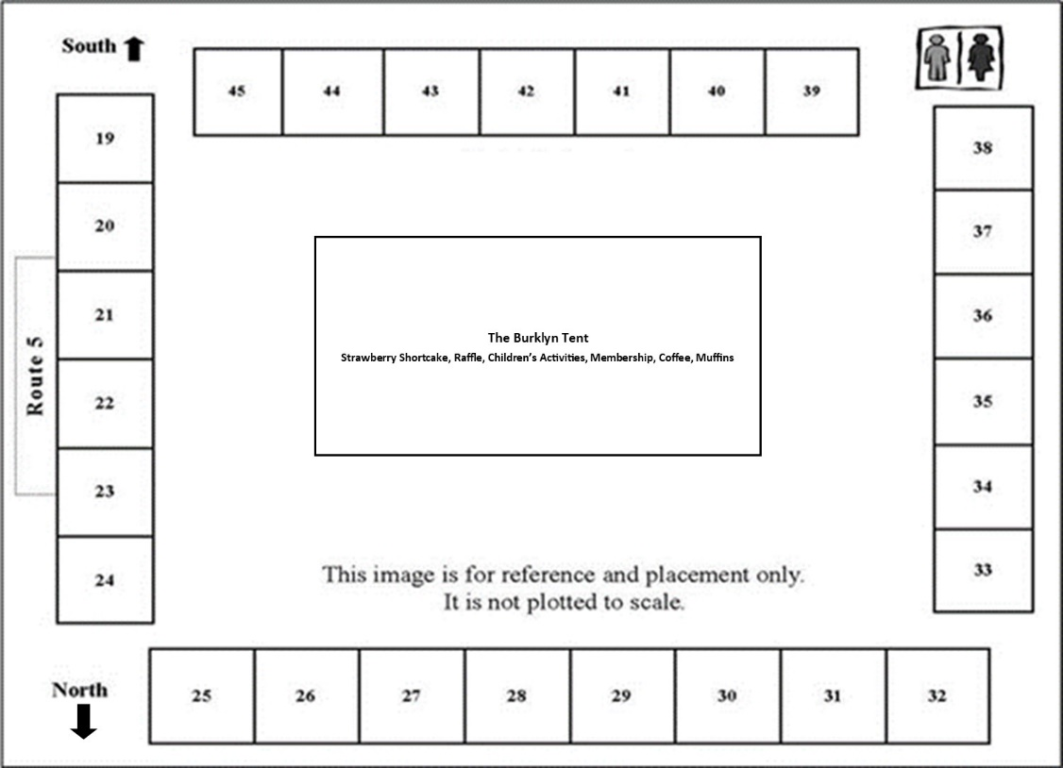
Fees are not refundable except as noted in the Application Guidelines.

Posters: Please help us publicize the fair. Can you hang card notices in your area (and thanks!)? Please send _________

Raffle: Burklyn greatly appreciates craft donations for our raffle! Raffle donation:_________________
valued at:_________

The undersigned exhibitor agrees to abide by the rules of the 50th Burklyn Summer Fair and will hold Burklyn Arts Council, Inc., harmless from injuries to any persons, from damages to property or from any losses resulting from participation in this event.

Signature _______________________________________________________________ Date_______________

